QuickRDA Modeling System

Operation Overview & Installation Guide

Erik Eidt

Version 2.7

March, 2011

***Copyright (c) 2011-2012 Hewlett-Packard Development Company, L.P.***

Operation Overview 5

User Spreadsheets 5

The QuickRDA Application 6

QuickRDA Tooling Code 6

Batch Files 6

Viewers 6

Open source graphing software 7

AT&T’s GraphViz 7

the ZGRViewer 7

Installation Guide 8

New Installation 9

Version Upgrade 10

Excel Add-In Version Upgrades 10

Upgrade to From Excel workbook to Excel Add-In versions 10

Remnants Removal 10

Customizing the batch files 11

Firefox 12

Chrome 12

Visio 12

GraphViz 13

ZGRViewer (optional) 14

References 15

GraphViz 15

Appendix: Installation Screen Shots 16

Firefox Installation Screen Shots 16

ZGRViewer Screenshots 20

***Table of Tables***

*No table of figures entries found.*

***Table of Figures***

Figure 1. QuickRDA Models 5

Figure 2. Pushpin for Add-In Install, Enable, Disable, and Uninstall 9

Figure 3. FireFox's Application Options for the Link Back Featurture 16

Figure 4. Changing the XYZ File Type Handler (Use other…) 17

Figure 5. Installing the XYZ File Type 18

Figure 6. Finding LinkBack.vbs In Your QuickRDA Installation Folder 19

Figure 7. ZGRViewer Charset Settings 20

Figure 8. ZGRViewer Directory Settings 21

# Operation Overview

The QuickRDA modeling system is a work in progress.

It currently consists of four parts:

1. Any number of user spreadsheets that contain RDA model elements,
2. The application itself, which requires Excel 2007 or 2010
3. Application dependencies on Open Source packages, namely GraphViz from AT&T.
4. Viewers for Scalable Vector Graphics, such as Mozilla Firefox.

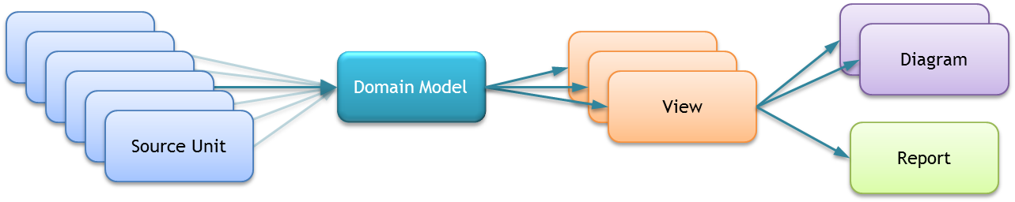

Figure 1. QuickRDA Models

The above diagram shows the flow of facts through the tooling in the construction of domain models and views.

## User Spreadsheets

The first part is of the QuickRDA modeling system consists of any number of user content spreadsheets, which are used to store RDA model elements.

To help create these spreadsheets, there are some templates that can be copied and populated. Additional templates can also be developed.

The standard template is a macro-free spreadsheet, called **QuickRDA Template.xlsx**.

*There is also an (even more) experimental macro-enabled template that can update the ZGRViewer automatically on changes to the user content spreadsheet modeling elements; not normally supplied.*

## The QuickRDA Application

The overall application consists of has two parts, namely the tooling code along with some batch files.

### QuickRDA Tooling Code

Since version 2.7, the primary QuickRDA tool component is in the form of an Excel Add-In, called:

**QuickRDA.xlam,**

This Add-In contains both:

* the RDA Domain Meta Models, schemas for describing RDA architectural layers, and,
* the executable code to manipulate template source units to transform user content spreadsheets into DOT language graphs, generate reports, etc…

### Batch Files

There are batch file for launching the result into the browser, and for running GraphViz, which consume the DOT language graphs and produce Scalable Vector Graphics (.svg) files. The batch files use the “start” command to launch the browser / viewer, so in fact, it will launch whatever program is assigned to the .svg file format under Windows’ Folder Options.

## Viewers

Any program capable of viewing .svg files can be used as a viewer, including:

* The Mozilla Firefox browser
* The Google Chrome browser
* Microsoft Internet Explorer (IE) — though IE requires a no-longer supported .svg plug-in available from Adobe
* Microsoft Office Visio
* The Open Source ZGRViewer

Firefox is the best choice, since it supports the QuickRDA tool’s link back feature, in which clicking on diagrammatic element (node or edge) switches back to the Excel spreadsheet that first defined the item.

The other browsers view the .svg alright, but do not support link back. Chrome is reported to work well, also. Visio is another alternative that works rather well, especially after the small startup delay on the first launch.

Internet Explorer (IE) does not yet support .svg files without installing an add-on. There is at least one source for such an add-on, namely the Adobe .svg add-on for IE; however it is no longer supported. I believe there might be one other add on for IE, though I don’t have details.

## Open source graphing software

GraphViz is the main engine that does the low-level diagrammatic generation and layout.

The ZGRViewer is an optional viewing engine, which has offers a different viewing experience. The largest benefit is the ability to refresh the diagram more quickly, though the initial launch of the viewer is slower than loading into.

### AT&T’s GraphViz

GraphViz is an open source graphing program from AT&T originally developed to diagram networking problems, but is much more general purpose than that. It’s been open-sourced for over 10 years and has a large following of developers.

Though its code can be embedded within an application, it is commonly used from the command line consuming an input file and producing an output file. The input file is in the AT&T-developed DOT language. Our preferred output is a scalable vector graphics (.svg) file.

### the ZGRViewer

The ZGRViewer is optional; it can be nice for viewing frequent changes to domain models. The ZGRViewer automatically runs GraphViz, and the QuickRDA modeling system can instruct the ZGRViewer to refresh itself, when using a spreadsheet based on the macro enabled template.

The ZGRViewer also has some interesting zoom and pan capabilities, as well as a find or search feature to locate graph nodes on the diagram.

# Installation Guide

As of version 2.7, the QuickRDA tool now ships as an Excel Add-In. The advantage to using the add-in flavor is that manual customization of:

* Excel’s Quick Access Toolbar (QAT) i*s not necessary*, and
* Excel’s Trust Center Settings *is also not necessary*.

Further, you will not see a second blank workbook when using the tool.

The disadvantage of using the add-in is that it is an Excel add-in, and it is loaded whenever Excel is used. However, the QuickRDA.xlam add-in is specifically programmed to run zero code on loading or unloading — it will only run code in response to its buttons being pressed. Also, if desired or necessary, it can easily be disabled via Excel’s add-in manager or by its own pushpin button.

*Other improvements in 2.7 eliminate the need for the QuickRDA environment variable, further simplifying installation. And one other improvement is that the tool now uses the approved TEMP location instead of its own folder for output and scratch files; they can be found in TEMP\QuickRDA.*

## New Installation

Choose a folder to be the long term installation folder for the distribution of the QuickRDA modeling system tooling & bits. This folder will be subsequently referred to as the QuickRDA installation folder. This folder will be for the application itself and some of its temporary files; it is not necessarily for your source units (models), which are probably best placed elsewhere.

Extract the contents of the QuickRDA Bits 2.7.zip file (or latest version) to this folder.

*Note: All these files need to be kept together in the same folder; in other words, don’t move the .xlam file to one of the several standard Excel Add-In folders.*

*Also note that for ease of future and regular updates to the tool, it is probably best that a version number is not applied to the name of the extracted folder (e.g. for this purpose, a folder named QuickRDA is better than QuickRDA 2.7).*

Then click on the file QuickRDA.xlam. If it asks to enable macros: say yes.

Click on the pushpin button in the Quick Access Toolbar and follow the instructions.

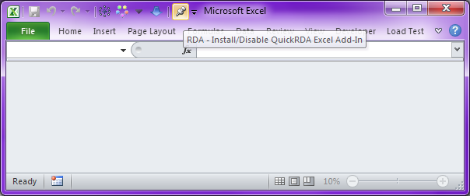

Figure 2. Pushpin for Add-In Install, Enable, Disable, and Uninstall

To make sure the installation is properly registered with your system, quit all running copies of Excel.

## Version Upgrade

To upgrade, all running copies of Excel should be closed.

### Excel Add-In Version Upgrades

For version upgrades post 2.7, where 2.7 or later was already installed, simply extract the QuickRDA Bits to the QuickRDA home folder, replacing the originals.

*Note: To change installation folder, you can use the Pushpin button to help (or do the equivalent manually). First, use it to disable the existing add-in. Then extract the QuickRDA bits to the new folder location, and then click on the QuickRDA.xlam file there. It will guide you through uninstalling the old version so that the new one can be installed. Note that uninstall is only needed when changing folders; it is not necessary to uninstall or even disable when upgrading in place — instead just make sure no copies of Excel are running).*

### Upgrade to From Excel workbook to Excel Add-In versions

For version upgrades from pre 2.7 to post 2.7, follow both:

* the Remnants Removal steps — outlined described below
* the New Installation steps — as described above in the New Installation section.

The order of these steps is not important, though we mildly suggest the above order because otherwise (but only until the 2nd step is finished) you’ll have duplicate QuickRDA buttons in Excel.

#### Remnants Removal

Remove the harmless but confusing Quick Access Toolbar (QAT) buttons associated with the .xlsm (pre 2.7) installation. If you have not provided any other Excel application-level QAT customization (which is likely) then you can simply reset the QAT — otherwise, delete the 1 to 5 (depending on version) individual QAT buttons associated with QuickRDA.

Other remnants can be removed, but are harmless. For more information see the supplemental document: Error! Reference source not found..

## Customizing the batch files

There are several batch files, the first of which may need to be customized after installing GraphViz, but only if necessary. This batch file searches currently known installation locations for GraphViz, so customization may not be necessary, in particular when GraphViz was installed to the default location.

* **StartBatchJob.bat** — This is the invoker of GraphViz .
  + If it is necessary (you will get errors using QuickRDA that .svg files are not found) then edit the dot.exe command on the third or so line to specify the correct location of dot.exe file from GraphViz. This file is located on your in the GraphViz installation folder, which is usually on your system drive in Program Files. For example:

C:\Program Files\GraphViz2.27\bin\dot.exe

On 64-bit windows, *Program Files* for will instead be *Program Files (x86)*, as follows:

C:\Program Files (x86)\GraphViz2.27\bin\dot.exe

* **StartBrowser.bat** — determines how to launch the viewer; however, it uses the windows start command, so customization to the Windows file associations for the .svg file will be used here automatically.
* **StartBatchBrowser.bat** — invokes the other two; requires the shell variable to be set.
* **StartZGRViewer.bat** — (*optional: only needed if you choose to install the optional ZGRViewer*) change the path name of the ZGRViewer application to the appropriate location of the .jar file on your hard drive.

## Firefox

To get the link back feature to work with Firefox, use Firefox to associate file type “xyz File” with “LinkBack.vbs”, which can be found in the QuickRDA installtion folder with.

For more information and screen shots have a look at the Firefox Installation Screen Shots.

## Chrome

Sadly, I haven’t yet figured out how to get Chrome to launch the .vbs script we need it to when you click on a node or edge hyperlink. The nodes & edges are hyperlinked to a file of type “.xyz”, which contains the information that QuickRDA needs to identify the row of interest. I’m able to get Firefox to launch files of type “.xyz” both directly with the LinkBack.vbs script as well as the LinkBack.bat batch file, which merely calls LinkBack.vbs. Of course, I’ve set Windows file associations (program defaults on later versions of Windows) for files of type “xyz” to the LinkBack.bat batch file, and when one clicks on a .xyz file using Windows Explorer: it has the desired action of sending you to the originating spreadsheet at a row of interest. Still no joy with Chrome, however; I thought it was supposed to follow the Windows file associations. (Note that Windows itself doesn’t work properly when setting the file association for “xyz” directly to the LinkBack.vbs script — it will give an error when trying to launch files of type xyz.) In any case, what we need to happen is that the hyperlink launches either LinkBack.vbs or LinkBack.bat with the (command line) argument having the name of the xyz file.

Another option that has been tried without luck also include using javascript-style links to directly launch the link back code without using a file intermediate — browsers did not accept this form; not sure why.

## Visio

Visio also works as an .svg viewer that does not support the link back feature. Note when using Visio, it may be tempting to save the generated .svg file (Visio prompts you to do so), *but don’t!* To share the .svg with others, use the .svg directly generated by the tool instead of saving the Visio as a .vsd or as an .svg file.

## GraphViz

You can download GraphViz from: <http://www.graphviz.org/Download_windows.php>.

I’ve tried both:

* the “current stable release”, **graphviz-2.26.3.msi**, as well as,
* the “development snapshot”, **graphviz-2.27.20100730.0445.msi**

I’ve not noticed any differences between them. I’m using the development snapshot.

They suggest — especially for Vista or Win7 — using a command line installation from an admin-privileged command line as follows, (but I don’t think I found it necessary).

msiexec /a graphviz-X.XX.msi

## ZGRViewer (optional)

The ZGRViewer can be obtained from <http://zvtm.sourceforge.net/zgrviewer.html>

It is open source and written in Java. I’ve downloaded the sources and built them using Eclipse. (I think the source base has some potential though there are other alternatives that may be better starting points for tooling development.)

The installation guide is in their web page in a section labeled “Setup”.

After following their guide, run the zgrviewer-xxx.jar file, and use View… Preferences… Directories to get to the settings where you can point ZGRViewer to the dot.exe file in GraphViz’s bin folder.

On the Misc tab, enter the following option for DOT/NEATO, specify -Gcharset=latin1 .You will want to use the “Save” button to save the misc settings and the directories settings — note that Apply & Close is not sufficient, you must use “save” for them to be preserved for the next run of the viewer.

The important setting here is the **DOT files directory** (which points at the dot.exe file, not the directory it is in). You’ll want to point ZGRViewer at:

when using a 32-bit Windows OS: “C:\Program Files\Graphviz2.27\bin\dot.exe”

when using a 64-bit Windows OS: “C:\Program Files (x86)\Graphviz2.27\bin\dot.exe”

Of course, substitute your system drive letter for C: and, your Program Files directory name appropriately, and specify the folder name of your GraphViz version).

The other executables can also be set similarly, though won’t be used by the QuickRDA modeling system.

And set the “DOT files directory” to your QuickRDA folder.

The fonts directory should be set to “C:\Program Files\Graphviz2.27\etc\fonts”, or your equivalent for the GraphViz installation. See the screenshots for more information: ZGRViewer Screenshots.

# References

##### GraphViz

For more information on the DOT language, see:

Website: <http://www.graphviz.org/>

Download: <http://www.graphviz.org/Download.php>

Documentation, basic syntax: <http://www.graphviz.org/doc/info/lang.html>

Documentation, attributes: <http://www.graphviz.org/doc/info/attrs.html>

# Appendix: Installation Screen Shots

## Firefox Installation Screen Shots

This is activates the link back feature with Firefox.

1. Use Firefox’s “Tools” menu to choose the “Options…” menu entry from the drop down, select the “Applications” tab, and,
   1. Check to see if you have the “XYZ or xyz” file type.

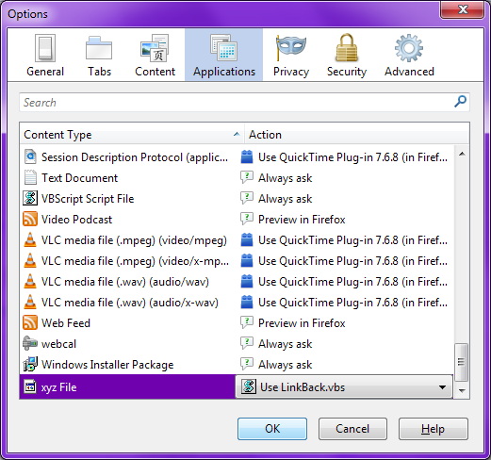

Figure 3. FireFox's Application Options for the Link Back Featurture

1. If you have the XYZ or xyz file type then:
   1. Then select the “xyz File” type from the list on the left;
   2. Next use the drop down opposite to the right to select “Use other…”, and,

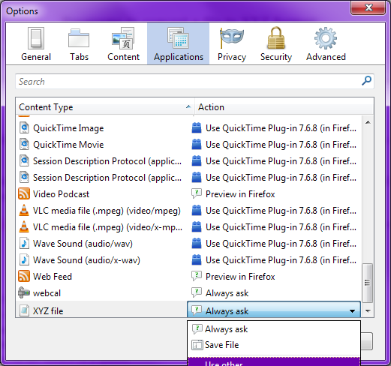

Figure 4. Changing the XYZ File Type Handler (Use other…)

1. If you DO NOT see XYZ or xyz file type in the list then:
   1. Navigate to a sample XYZ file on the net. Here’s one:

<http://people.sc.fsu.edu/~jburkardt/data/xyz/cube.xyz>

*(From* [*http://people.sc.fsu.edu/~jburkardt/data/xyz/xyz.html*](http://people.sc.fsu.edu/~jburkardt/data/xyz/xyz.html)*; it is “cube.xyz” link in the “Sample XYZ files” section of that page.)*

* 1. Make sure to select the “Do this automatically”, then chose “Other…”

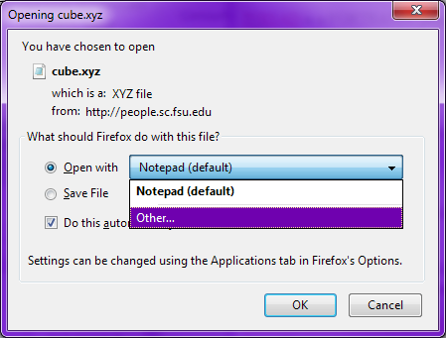

Figure 5. Installing the XYZ File Type

1. Use “Browse…” to Select LinkBack.vbs from your selected QuickRDA installation folder.

***Note that you will not see LinkBack.vbs listed here, so once you navigate to the QuickRDA installation folder location, therefore, YOU MUST TYPE into the File name: text box LinkBack.vbs (or at minimum type an L and then select from the dropdown) and click OK***.

*Also note that there is also a LinkBack.bat file here for other browsers to use as needed; however, it is not necessary for FireFox, and using it with FireFox will work but with slightly higher visual overhead of having a blank batch file flash to the screen before retreating.*

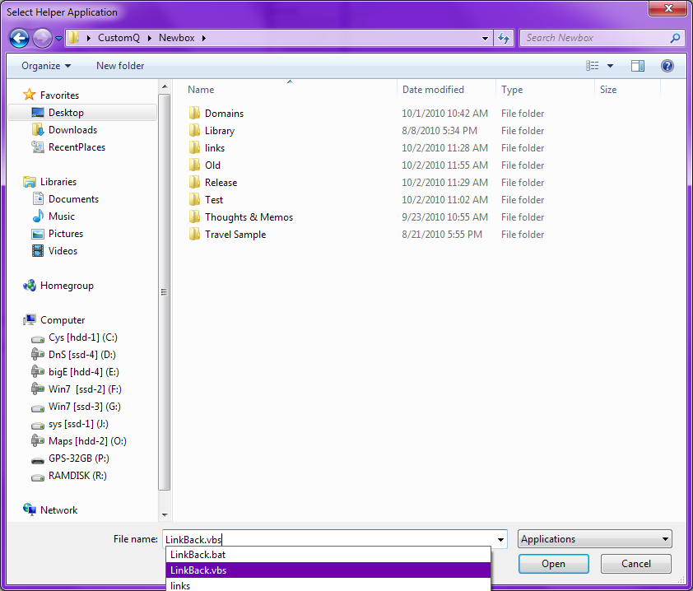

Figure 6. Finding LinkBack.vbs In Your QuickRDA Installation Folder

## ZGRViewer Screenshots

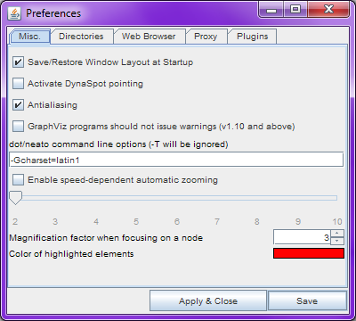

Figure 7. ZGRViewer Charset Settings

After applying misc/charset and directory settings, be sure to use Save, in addition to Apply & Close, or the settings will not be preserved for the next launch of the viewer.

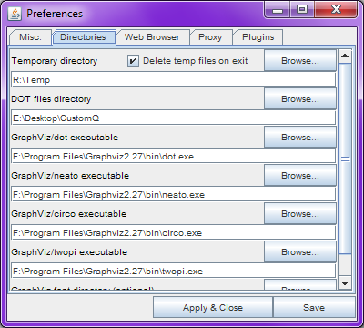

Figure 8. ZGRViewer Directory Settings

After applying misc/charset and directory settings*, be sure to use “Save”, in addition to “Apply & Close”*, or the settings will not be preserved for the next launch of the viewer.